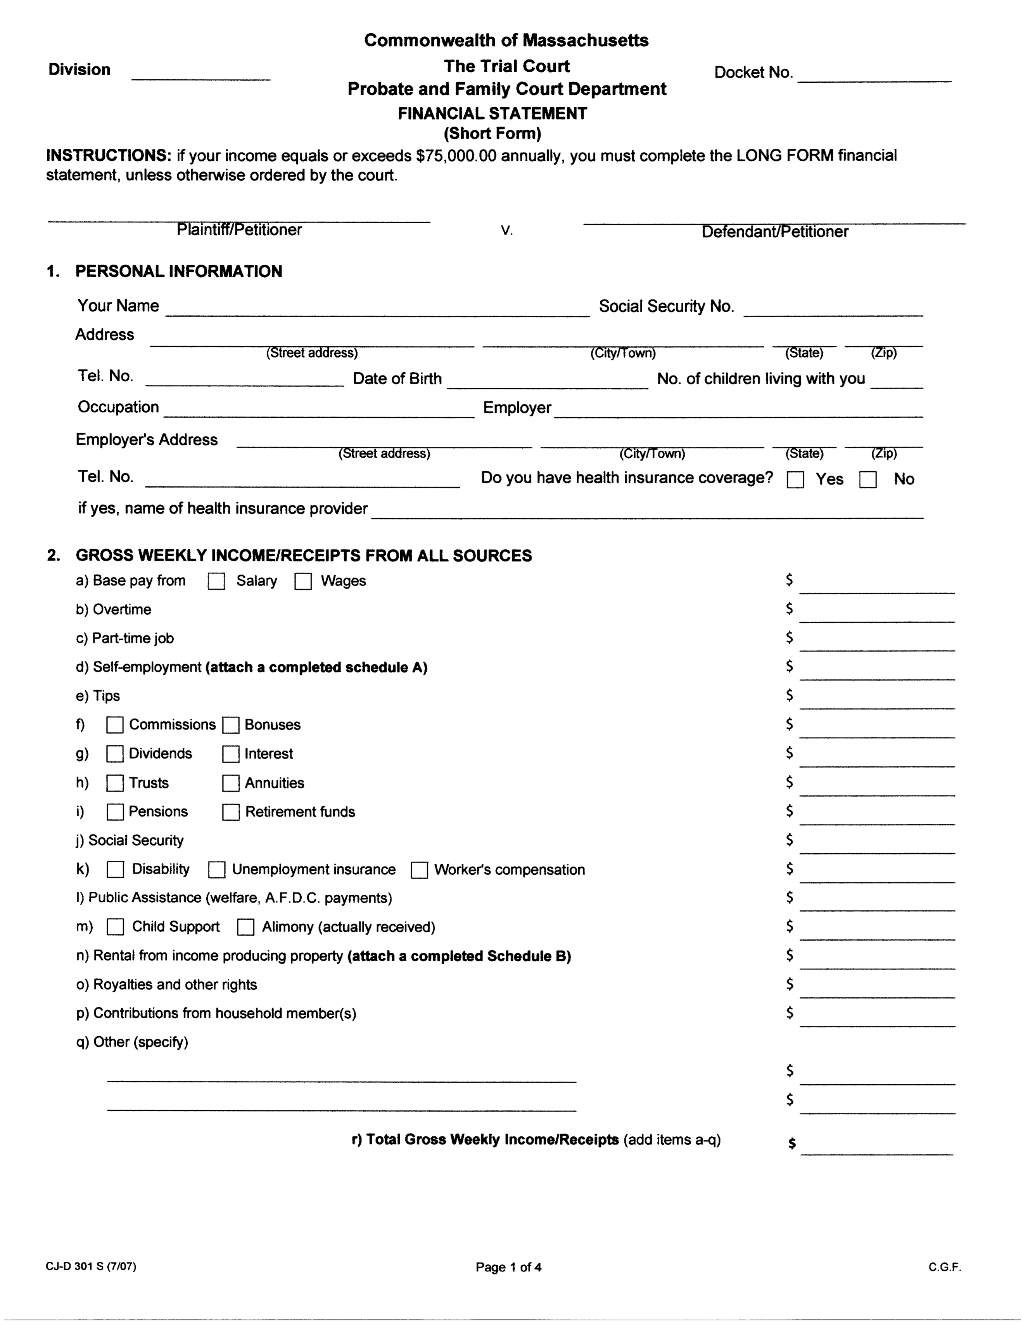

|  |
| --- |
| Pretend Client |

|  |  |  |  |
| --- | --- | --- | --- |
| 123 Best St | Boston | MA | 2112.0 |

|  |
| --- |
| 617-999-9999 |

|  |
| --- |
| 1/15/1987 |

|  |  |  |
| --- | --- | --- |
|  |  |  |

|  |
| --- |
|  |

|  |
| --- |
| 617-999-9999 |

|  |
| --- |
|  |

|  |
| --- |
| Unemployed |

|  |
| --- |
|  |

|  |
| --- |
|  |

|  |
| --- |
|  |

|  |
| --- |
|  |

|  |
| --- |
|  |

|  |
| --- |
|  |

|  |
| --- |
|  |

|  |
| --- |
|  |

|  |
| --- |
|  |

|  |
| --- |
|  |

|  |
| --- |
| 200.0 |

|  |
| --- |
|  |

|  |
| --- |
|  |

|  |
| --- |
|  |

|  |
| --- |
|  |

|  |
| --- |
|  |

|  |
| --- |
|  |

|  |
| --- |
| #VALUE! |

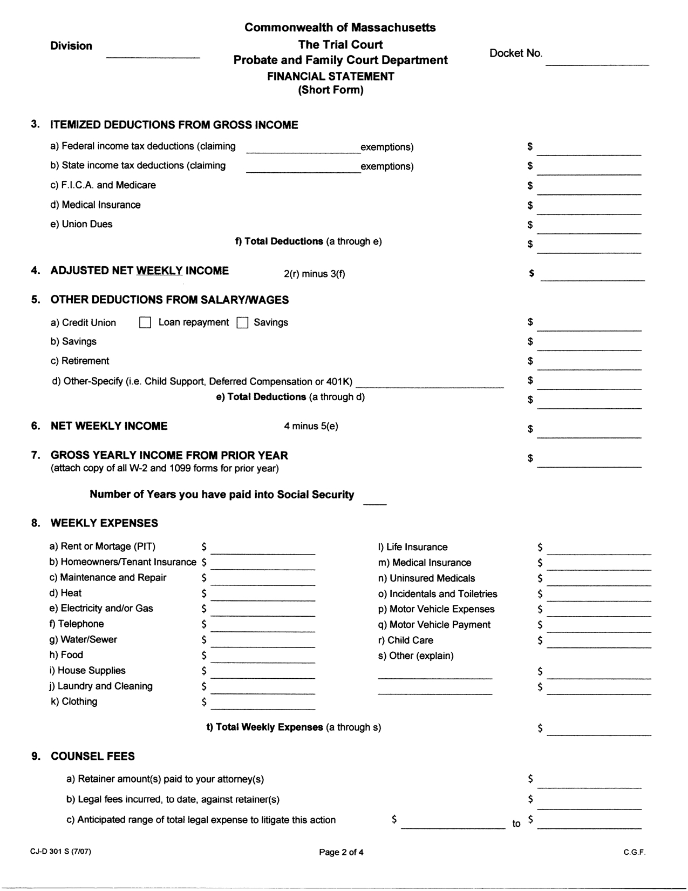

|  |
| --- |
|  |

|  |
| --- |
|  |

|  |
| --- |
|  |

|  |
| --- |
|  |

|  |
| --- |
|  |

|  |
| --- |
|  |

|  |
| --- |
|  |

|  |
| --- |
|  |

|  |
| --- |
|  |

|  |
| --- |
|  |

|  |
| --- |
|  |

|  |
| --- |
|  |

|  |
| --- |
|  |

|  |
| --- |
| Unsure |

|  |
| --- |
| 1500.0 |
| Don't know |
| Unsure |
| 100 per month |
| 50 per month |
| 50 per month |
| Included in rent |
| Approximately 100 per month |
| Approximately 50 per month |
| Approximately 20 per month |
| For the kids, approx 50 per month |

|  |
| --- |
|  |
|  |
|  |
| Approximately 20 per month |
|  |
|  |
|  |
|  |
|  |
|  |

|  |
| --- |
| #VALUE! |

|  |
| --- |
|  |
|  |
|  |

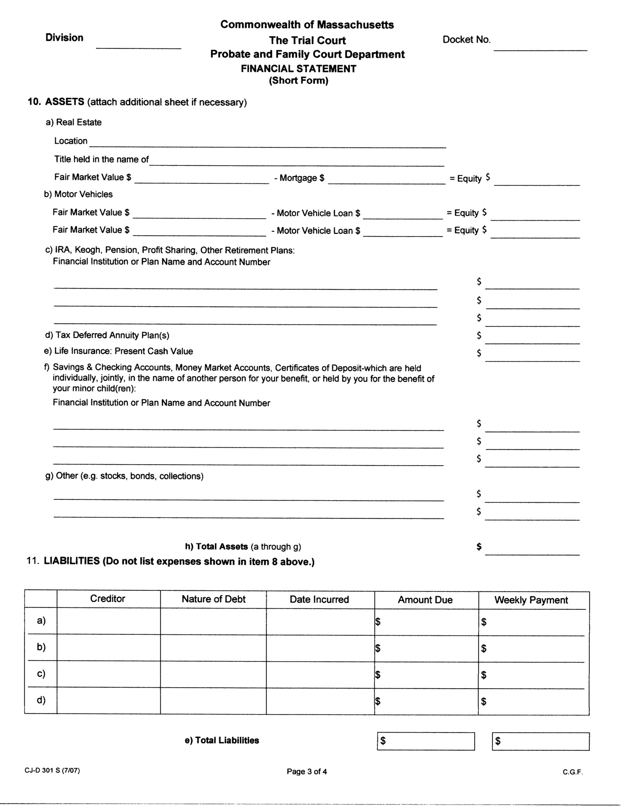

|  |  |  |  |  |
| --- | --- | --- | --- | --- |
| My friend - Priyanka Chopra |  | 12/1/2017 | 400 dollars | 10 dollars |

|  |  |  |  |  |
| --- | --- | --- | --- | --- |
| Capital One |  |  | 500 dollars | 20 dollars |

|  |  |  |  |  |
| --- | --- | --- | --- | --- |
|  |  |  |  |  |

|  |  |  |  |  |
| --- | --- | --- | --- | --- |
|  |  |  |  |  |

|  |  |
| --- | --- |
|  |  |

